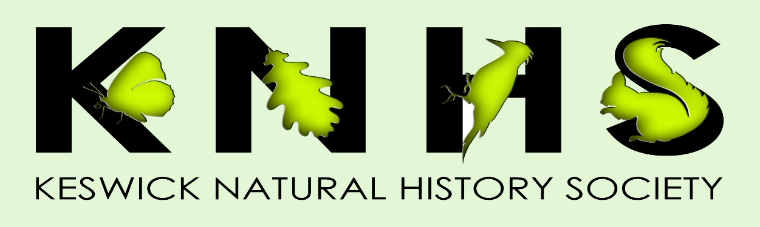

Indoor Lecture Programme 2023/24

Oct 5 Chris Winnick Butterflies of Cumbria
Chris is the Chair of Butterfly Conservation, Cumbria branch. His presentation will focus on the work of Butterfly Conservation and the species found in Cumbria.
Oct 19 Jack Brennand Peatland Conservation
Jack works for the University of Cumbria and partners with a local company to evaluate blanket peatland restoration projects using innovative 3D X-ray CT scans. He will explain his work and tell us how it is helping to provide a nature-based solution to the climate crisis.
Nov 2 Jackie Foott Red Squirrel Conservation
Jackie has been involved in red Squirrel conservation in the UK for over 30 years. She now runs British Red Squirrel, a UK based information hub. She will talk about conservation of red squirrels both locally and nationally.
Nov 16 Kevin Scott Cumbria Wildlife Trust - Our Local Reserves
Kevin is Cumbria Wildlife Trust’s Northern Reserves Manager. He will be talking to us about the Cumbria Wildlife Trust reserves at Eycott Hill, near Berrier, Penrith and at Dubbs Moss, near Cockermouth.
Nov 30 Phillip Munro Supporting Golden Eagles in South Scotland
Philip works for the South of Scotland Golden Eagle Project and will tell us about the projects work reinforcing the small Golden Eagle population in Southern Scotland.
Jan 11 Alan Smith What the Ice-age did for Keswick
Ex-chairman of KNHS, Alan, will discuss how the Ice-age shaped the foundations of our natural world, and how it affected the flora and fauna in our local area.

Jan 25 Julia Hoggard Bees and Hay Meadows
Julia is an experienced beekeeper from the Kendal area. She is the education officer for Kendal & South Westmorland Beekeepers’ Association and runs BeeEd, a not-for-profit organisation. Her talk about bees and hay meadows will include advice about how we can develop a mini garden hay meadow at home and look at the way flowers and pollinators interact.
Feb 8 Stuart Sharp Ecology and Conservation of River Birds
Stuart works for Lancaster University’s Environment Centre, a teaching and research facility, where he carries out long-term studies of our river birds. He will talk to us about his research on these species, covering aspects of their behavioural and population ecology, and the conservation challenges they face.
Feb 22 Stephanie Johnstone Pine Martens
Stephanie Is Chair of the Dumfries and Galloway Pine Martens Group and has most recently been working on pine marten conservation in various locations in Scotland England and Wales for the Vincent Wildlife Trust. She will talk to us about the history and ecology of pine martens in Britain and current conservation efforts for the species.

March 7 AGM
The AGM will be followed by a talk and slide show by the Chair of KNHS, Tony Marsh. Using his photographs, he will share experiences from all of the recent KNHS field trips.

